I'm making plant milk, and this is my first recipe that I'm actually documenting properly. I've been experimenting with this for a while, but figured it's time to share what I've learned :-)

## **Why Sunflower Seeds?**

Sunflower seed is, in my opinion, an optimal choice for making nut milk. Even though it's a seed, it's a seed milk. Here's why it's so good: it contains natural lecithin, which is a natural emulsifier, meaning it prevents the liquids and the fats from separating.

That means it's ideal for use with coffee - it's already barista nut milk! Unlike others, like oat milk or almond milk, which tend to separate when you put boiling water with them, the sunflower seed stays together very well. For this reason, it's also quite good for adding to other milks to get the natural lecithin effect.

## **The Recipe**

### **Ingredients**

* 42 grams sunflower seeds (before being soaked overnight)
* 17 grams barhi dates (2 dates without the pits)
* 1.1 liters water (to fill the bottle and leave a little left over for tasting)
* 0.42 grams salt (yeah, I like the number 42, thats basically a pinch)

### **Equipment**

* Blender
* Nut milk bag
* Large jug (I use a 5-liter one)
* Funnel
* 1-liter bottle for storing

### **Instructions**

1. Prep the night before: Soak 42 grams of dry sunflower seeds overnight.
2. 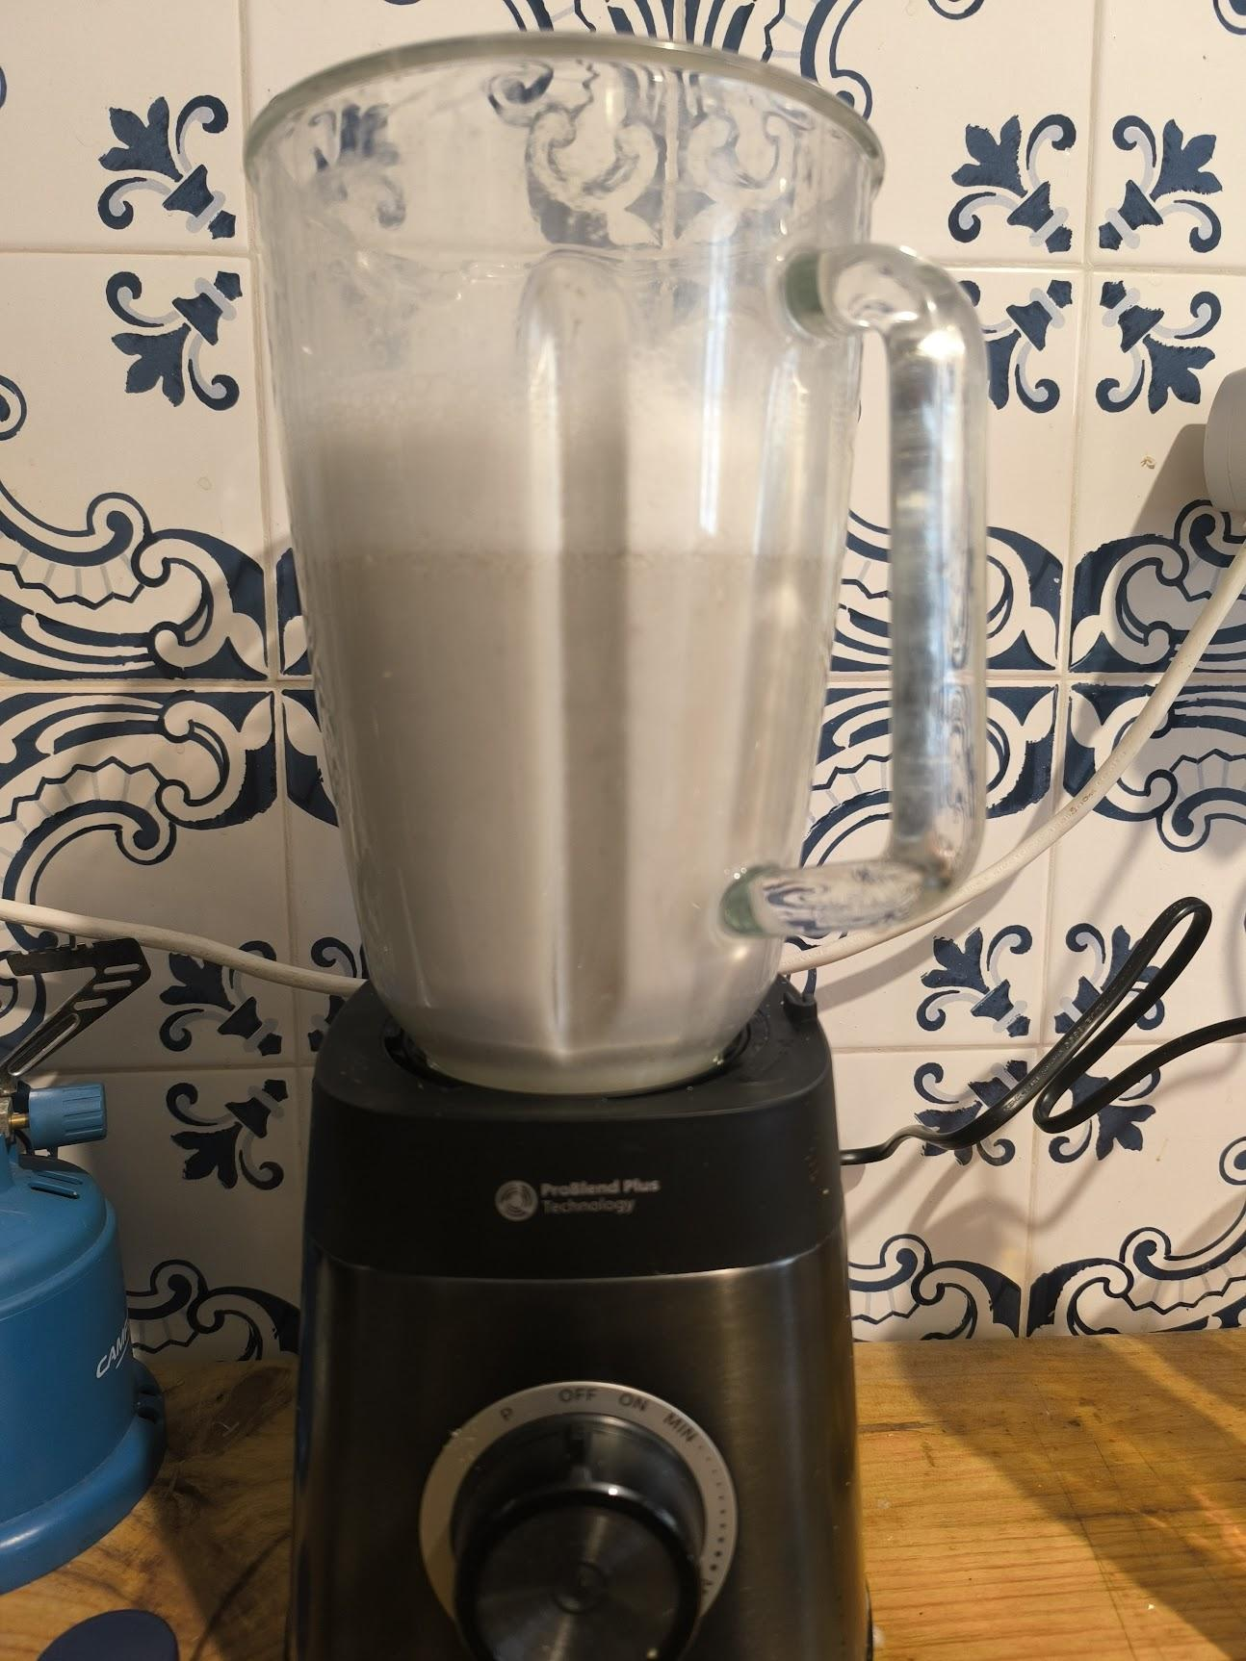Blend it up: Throw the soaked seeds, dates, and salt into your blender. Add the 1.1 liters of water (I use a bit extra because I want to end up with 1 liter in the end, plus a little for tasting and accounting for what gets left in the pulp).
3. Blend carefully: I blend for about 30 seconds. Here's the thing - if you have a really good blender like I do, you gotta be careful not to over-blend. If you do too much blending, the particles get so fine that they go through your nut bag, which defeats the purpose.
4. Taste test: Take a spoon and taste it. At this point, it's already pretty good! It has a slightly gray color and tastes a little bit sunflower seed-y, which for me is quite tasty. You can actually use it like this if you're adding it to oats - you can whip this up in a matter of minutes.
5. Strain it: Pour it into your nut sack (nut milk bag). This is where having a big jug helps - the nut sack hooks around really nicely, otherwise this part is kinda tricky if you're on your own.

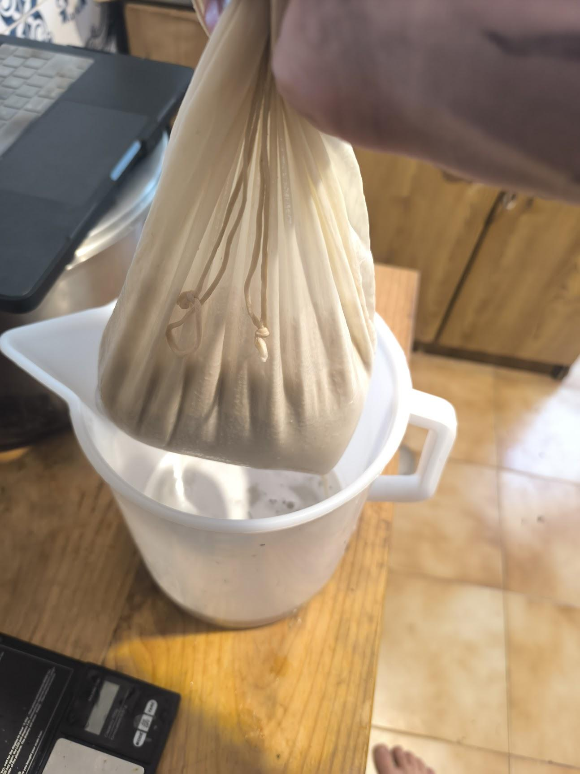

1. Squeezy squeezy time! Squeeze that bag to get all the good milk out. You'll be left with a teeny little bowl of fibery stuff which you can use to put in your oats or throw it in the compost. Dont put it in the general trash! or it will be robbed of the chance to decopmpose into valuable food for other organisms  
   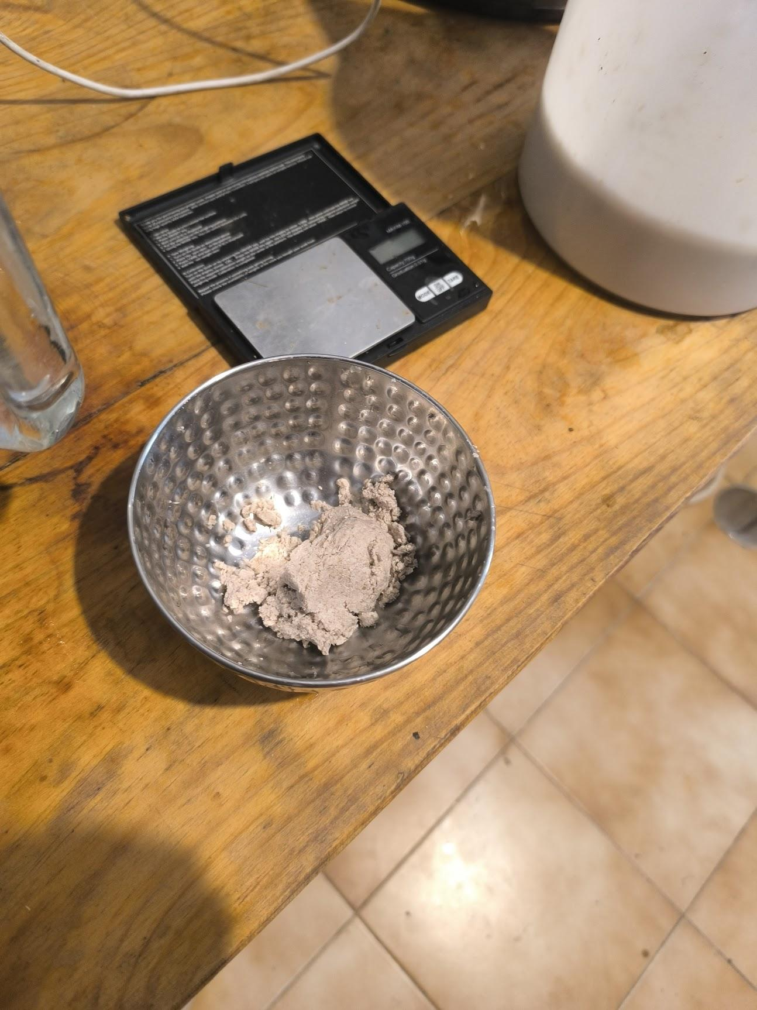

## **The Results**

You end up with about 1.1 liters of creamy, grey sunflower seed milk. It's definitely creamy enough for most use cases, though it could be more creamy. Maybe next time I'll go up to 50 grams, even 60 grams per liter.

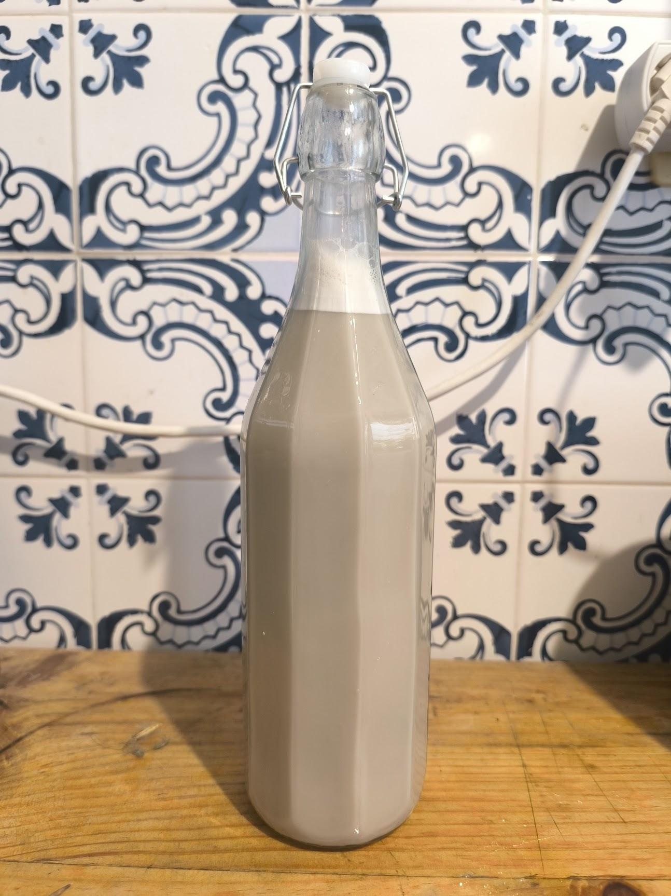

### **Taste & Texture**

It tastes nutty actually, even though it's a seed. To be honest, it's not super tasty on its own - it's pretty much plain. For me, this is like the plain milk for the cuisine, plain milk for the coffee, plain milk for adding to food, to soups, whatever it is you want to add it to. It's good milk, but it's not super special to drink straight.

If you want to add it to cacao with a bit of agave syrup though, I think it's really the perfect thing.

## **Storage & Shelf Life**

If you want this to last a long time, you're really gonna have to maybe pasteurize it - heat it up to 80 degrees and let it stay there for 10 minutes. Make sure your bottles are sterilized too, probably with boiling water.

Otherwise it's gonna go bad within probably 24 hours, even in the fridge. It's probably still good after 24 hours, but much more than that, it's gonna be smelling funky. Which is not always bad - sometimes my soy milk turned funky in a really nice way, it was basically liquid yogurt, and we were eating it and it was really good.

## **Don't Waste the Pulp!**

That leftover fibery stuff? Don't throw it in the regular trash! Chuck it in your compost - it's pretty good for the compost. If you throw it in regular trash, it goes to a landfill and gets robbed of its chance to compost and turn back into life-giving fuel for other organisms.

## **What's Next?**

This is my first documented recipe, but I think I'll be experimenting with various different recipes. Next time I might add some other nuts to the mix and see how that changes things.

For us vegans, we don't really care if it tastes like regular milk. We want milk to be creamy and ready to add to things to add a bit of creaminess - and this definitely delivers on that front.